**Forms: The Interactive Checkpoints of Your Webpage**

Imagine your house having designated areas for visitors to interact with you. Forms in HTML are like these interactive elements, allowing users to submit information. Let's explore the building blocks that create these forms:

**The <form> Element: The Blueprint for Interaction**

The <form> element acts as the foundation for your form, just like the blueprint for your designated interaction zone in the house. It defines the container that will hold all the interactive elements like text fields, buttons, and more.

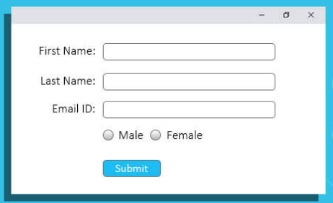

**The <input> Element: The Workhorse of Forms**

The <input> element is the workhorse of forms, representing the various input fields users interact with. It comes in different type attributes to cater to specific needs:

* **Text Fields:** Imagine a guestbook where visitors write their names. Text fields (type="text") are similar, allowing users to enter single-line text input.
* **Password Fields:** For secure information like passwords, the type="password" hides the characters as the user types, adding a layer of security.
* **Email Fields:** Need users to enter their email addresses? The type="email" ensures the browser validates the format for a proper email address.
* **And Many More!** There are numerous other <input> types like checkboxes, radio buttons, and more, each serving a specific purpose.

**The <label> Element: The Guiding Hand**

Imagine placing labels next to your guestbook to guide visitors. The <label> element acts similarly, associating a text label with a specific <input> element. Clicking the label automatically focuses the user on the corresponding input field, improving usability.

**Radio Buttons: Making Exclusive Choices**

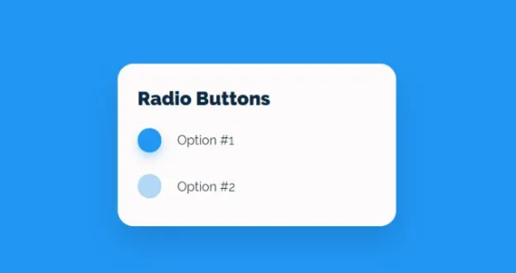

Imagine a group of buttons where only one can be selected at a time, like choosing your favorite beverage from a menu. Radio buttons (type="radio") function similarly, allowing users to select just one option from a predefined set within a form.

**Checkboxes: Picking Multiple Options**

Think of a permission form where users can choose multiple options. Checkboxes (type="checkbox") allow users to select multiple choices from a set of options within the form.

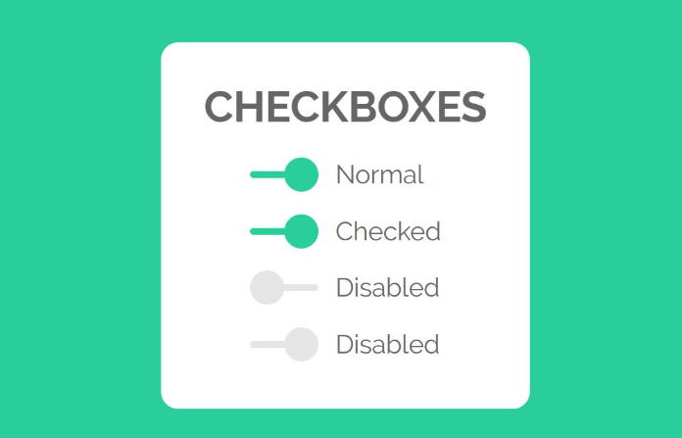

**The Submit Button: Taking Action**

The submit button is like the doorbell at your designated interaction zone. It triggers the form submission process (type="submit") when clicked, sending the collected information to the server for processing.

**The Name Attribute for <input>: Assigning Identities**

Imagine giving each guestbook entry a unique name for identification. The name attribute for the <input> element does exactly that. It assigns a unique name to each input field, allowing the server to identify and process the submitted data effectively.

**HTML Form Attributes: Fine-Tuning the Experience**

There are several attributes you can use with the <form> element to control the form's behavior:

* **The action attribute:** This specifies the URL where the form data will be sent upon submission. Imagine it as the address on your doorbell, directing information to the right place.
* **The target attribute:** This defines where the submitted form data will be displayed after processing. Imagine different rooms in your house; target="_blank" opens the response in a new window, while target="_self" keeps it in the current window.
* **The method attribute:** This determines how form data is sent to the server. Typically, method="post" is used for sensitive data, while method="get" is used for simpler data retrieval.
* **Other attributes:** There are additional attributes like autocomplete to manage browser suggestions and novalidate to disable browser-side validation.

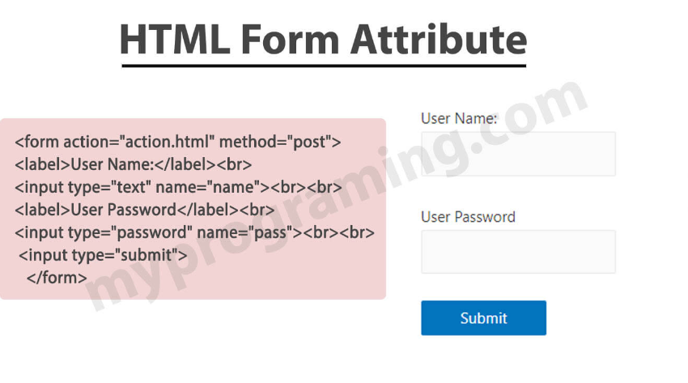

**Forms: The Interactive Checkpoints of Your Webpage**

Imagine your house having designated areas for visitors to interact with you. Forms in HTML are like these interactive elements, allowing users to submit information. Let's explore the building blocks that create these forms:

**The <form> Element: The Blueprint for Interaction**

The <form> element acts as the foundation for your form, just like the blueprint for your designated interaction zone in the house. It defines the container that will hold all the interactive elements like text fields, buttons, and more.

**The <label> Element: The Guiding Hand**

Imagine placing labels next to your guestbook to guide visitors. The <label> element acts similarly, associating a text label with a specific <input> element. Clicking the label automatically focuses the user on the corresponding input field, improving usability.

**A Speedy Reference: List of All <form> Attributes**

For a comprehensive list of all <form> attributes and their functionalities, searching online for "HTML form attributes reference" will provide detailed explanations.

**Exploring Further: HTML Form Elements and Attributes**

As you delve deeper, you'll discover a vast array of HTML form elements and attributes, each catering to specific data collection needs. Explore online resources like <https://developer.mozilla.org/en-US/docs/Web/HTML/Element/input> to understand the different input types and their attributes.

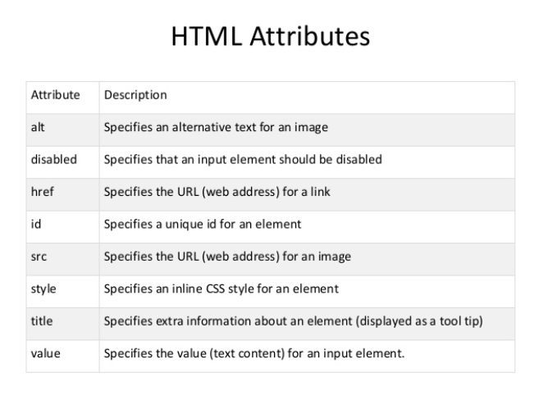

**The Building Blocks of Interactive Webpages: Unveiling HTML Forms**

Imagine your house with designated areas for visitors to interact with you. HTML forms are like these interactive elements, allowing users to submit information. Let's explore the essential components that bring forms to life:

**HTML Input Types: Specifying the Data You Want**

Think of input types as different colored buckets for collecting specific information. Here are some common types:

* **Text (type="text"):** A general-purpose bucket for single-line text input.
* **Password (type="password"):** A secure bucket that hides characters as the user types, ideal for passwords.
* **Email (type="email"):** A bucket that validates the format for a proper email address.
* **Number (type="number"):** A bucket that restricts input to numbers, often with additional attributes like minimum and maximum values.
* **Checkbox (type="checkbox"):** A bucket that allows users to select multiple options from a set.
* **Radio Button (type="radio"):** A bucket that allows users to select only one option from a predefined set.
* **Date (type="date"):** A bucket that pops up a calendar for users to select a date.
* **URL (type="url"):** A bucket that validates the format for a proper web address.
* **And many more!** Explore the options available to match your specific data collection needs.

**HTML Input Attributes: Fine-Tuning the Input Fields**

These attributes add specific functionalities to your input elements:

* **name:** Assigns a unique name to each input field, allowing the server to identify and process the submitted data effectively. Imagine giving each guestbook entry a unique name.
* **value:** Sets the default value displayed in the input field before the user interacts with it.
* **placeholder:** Provides a hint or light grey text within the input field, guiding users on what kind of information to enter. Imagine a placeholder in your guestbook that says "Enter your name".
* **required:** Makes a field mandatory, preventing form submission until the user fills it in.
* **disabled:** Makes a field uneditable by the user.
* **There are many more!** Explore different attributes to control behavior, validation, and appearance of your input fields.

**Debunking the Myth: There is no form* Attribute in HTML**

While the prompt mentions HTML Input form* Attributes, there isn't a specific category named form* within HTML input attributes. The attributes mentioned in point 3 (like name, value, and required) are all individual attributes used with the <input> element to control its behavior.